**AN USEFUL AWS POWERED APPLICATION FOR EVENT ANNOUNCEMENT ALERTS**

**EVENT ANNOUNCEMENT SYTEM USING AWS AND ITS SERVICES**

AWS SERVICES USED AND OTHERS:

1.

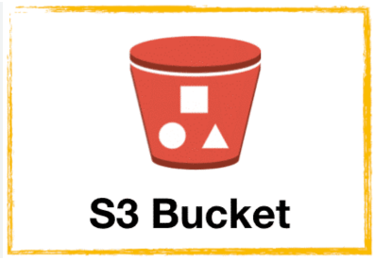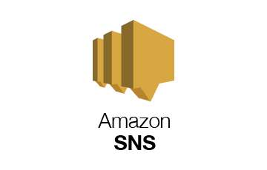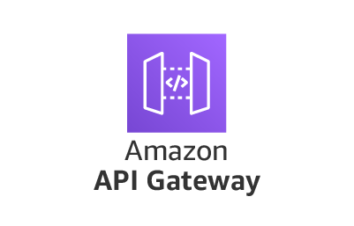

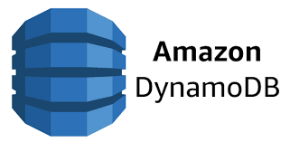





**Amazon S3:**  
Used to host static frontend files and serve the website over the internet.

**API Gateway:**  
Acts as the entry point for HTTP requests, routing them to the appropriate backend service.

**AWS Lambda:**  
Handles backend logic and processing when triggered by API Gateway.

**Amazon DynamoDB:**  
Stores structured data with low latency and high availability.

**Amazon SNS:**  
Sends notifications (e.g., emails) to subscribers when triggered by backend events.

**IAM Roles:**  
Manage permissions and securely allow services like Lambda to access DynamoDB and SNS.

**JWT:**  
Used for verifying user identity and controlling access to protected resources.

Architecture diagram:

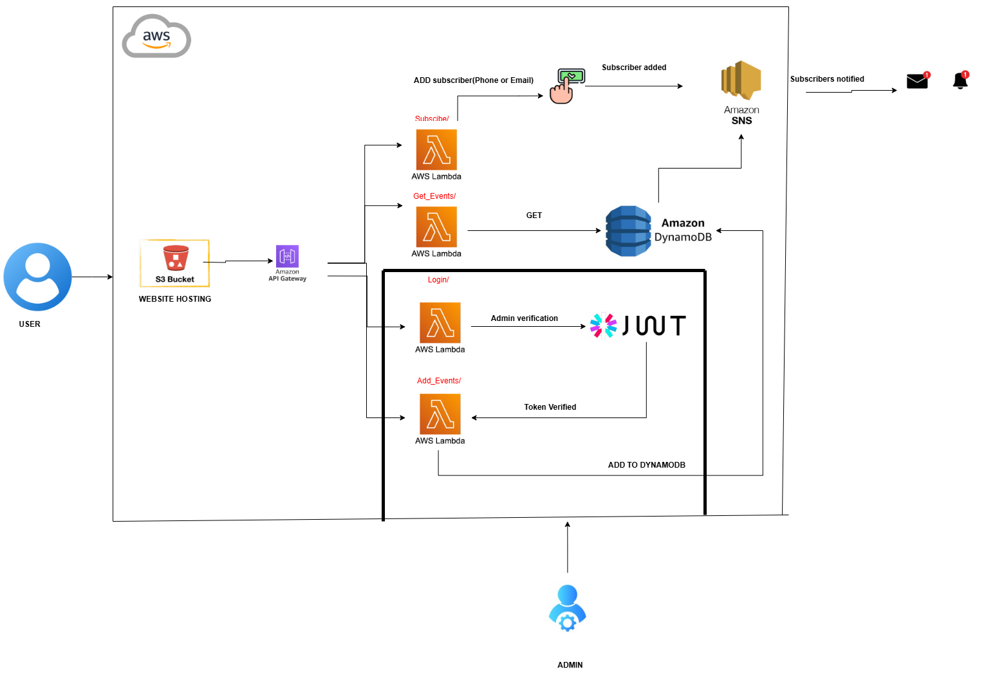

Creation of DynamoDB table:

event_id acts as a partition key:

Creation of topic for saving subscribers information:

ARN:

arn:aws:sns:us-east-1:009160062593:EventNotification

Get_events lambda function retrieves events from Dynamo table:

Subscribe function facilitates new subscriber add on through confirmation:

Addition of lambda function routes into the API (Event_API):

Creation of stage ensures stage of development and deployment of application:

<https://9xo1fujxn3.execute-api.us-east-1.amazonaws.com/stage_event>

Uploading frontend code to S3 bucket:

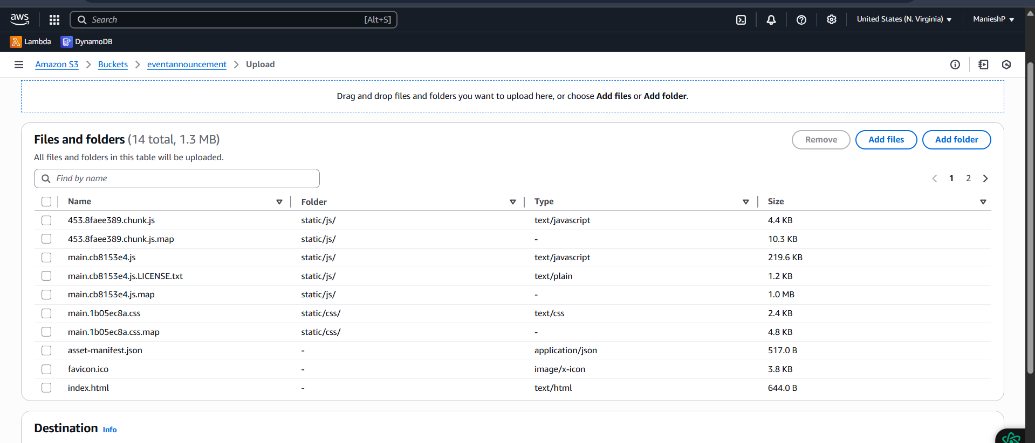

Addition of IAM roles to the Add event function to be invoked only when admin logins:

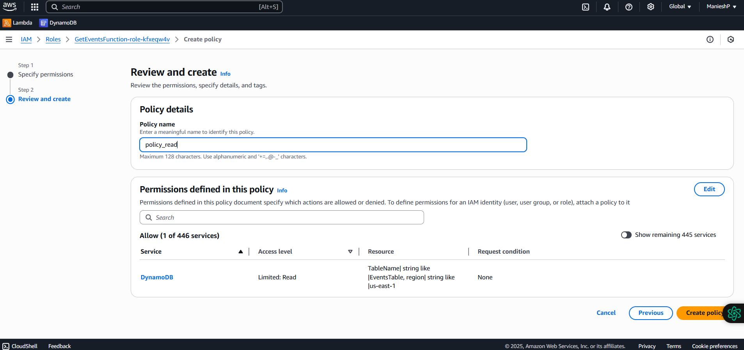

Working:



